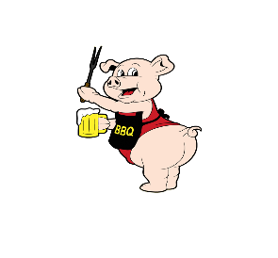
2020 Volleyball Registration
Circle: Mon Tue Wed Thurs
Team Name:
Captain’s Name:
Captain’s Phone:
Captain’s Email:
Additional Phone Numbers:

PayPal:
(Please write Transaction ID from PayPal Receipt)
PayPal E-mail: greatfood@triplepbbq.com
Modified Season
Mon 4 Man Team - $50
Tues/Wed/Thurs: $175
Registration due by June 15
Season Starts July 6, 2020

