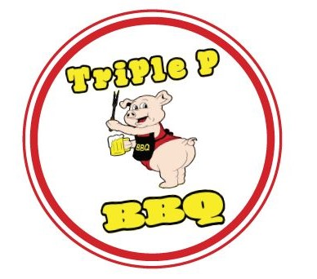
Cook-Off
Chili
Inaugural

9:00 am — 2:00 pm Sunday, October 4th, 2019 Triple P BBQ
3312 W. Route 30, Rock Falls, IL
Includes contest contestant, serving to 1:30 pm
Prize Information
Cash Prizes to be awarded!
Contestants
$30 Per Team

Judging Criteria
Judging will observe presentation, aroma, consistency, color and flavor.
General Public
$5 at the door day of event, includes one tasting ticket per contestant, serving to commence at 1:30 pm.

People’s Choice
Our guests will judge each contestant’s entry to declare the Best Overall!

Inquiries may be directed to, Shane Porter at 815-625-7138 or greatfood@triplepbbq.com
Need Signage or Team Gear Assistance? Call Shane today for a referral to one of our trusted partners!
2019 TRIPLE P BBQ CHILI COOK-OFF December 8, 2019 from 9am—2pm Register by December 1, 2019.
$30 per team
Team Name: _______________________________________________ Chief Cook/Contact: ______________________________________ Chief Cook Phone: ________________________________________ Chief Cook E-mail: ________________________________________ City:________________________________________
Have you ever competed before? Yes No
If yes, how many competitions? ___________________________
By signing, I agree that I have read all Contest Rules and I under- stand that my entrance fee is non-refundable.
Signature: __________________________________________________
Date: _______________________________________________________

Chili
Inaugural

Contest Rules

- ⇒ Check—In starts at 8:00 am Sunday, October 4th, 2020.
- ⇒ Serving Cups, Spoons & a Garnish Bar will be provided.
- ⇒ Only one entry per contestant, no sharing.
- ⇒ Cooking method of your choice.
- ⇒ Turn In time will be at 1:00 p.m.
- ⇒ Cooking sites will be assigned/chosen upon arrival, making use of the patio first, then parking lot if more space is needed. You are required to bring signage displaying your Team Name.
- ⇒ Entry platter will be assigned at 12:30pm with each contestant’s own entry number.
- ⇒ A “Turn-in” of 6 - 8 half cup (1/2 c.) servings of chili will be expected. All bowls turned in must have been cooked as one larger serving.
- ⇒ Entries will be judged on five criteria to arrive at one whole-number score of 1 to 10 with 10 being the highest. The five criteria are:
*Presentation *Aroma *Consistency *Color *Flavor
- ⇒ Clean, safe food handling is a must! Triple P will be recording temperatures for each item and the Whiteside County Health Department will be on site to be sure all contestants are following safe handling procedures. Hand-wash stations will be provided.
- ⇒ Winners will be announced on site between 1:30pm-2:00pm.

